**EDF 6432**

**Measurement & Evaluation in Education**

**Final Project**

**Spring 2017**

**G5:**

**Jeanine Bruno**

**Rebecca Hoholski**

**Richard Knop**

**Gabriel Yeager**

**Context**

The learning environment consists of 10 to 15 high school students in grades 9 to 12 including accommodations for one to two English Language Learners (ELL L2) learners, one Exceptional Student Education (ESE) Autistic Spectrum Disorder, and one ADHD student with a 504 plan; within a support facilitated classroom environment.

To assess students’ proficiency sample criterion-based test questions were designed for students in grades 9 to 12, ages 14 to 19, studying a unit of Art History/Visual Arts during the 20th Century.

● Level: *Grade 9-12*

● Subject: *Visual Arts*

● Unit of instruction: *A unit of 20th Century Art History/Visual Arts*

● Test type: *Criterion-referenced test*

*The purpose of the test is to assess a student’s progress, application of the concepts presented in the unit of instruction, and a letter grade toward meeting the instructional objectives for a module in Art History. The test results will inform the instructor of the student’s proficiency of the course material aligned with the Next Generation Sunshine State Standards (NGSSS).*

**Accommodations**

Specific accommodations for those with Exceptional Student Education (ESE) and Limited English Speaker (LES)/ English Language Learners (ELL) will be provided to students as outlined in their Individual Education Plan (IEP), where appropriate, and where the student may be in their proficiency of the English language. Based on the collaborative work of the IEP or Section 504 Team, the parents, the student, and the instructor; accommodations will be implemented considering the Student, the Environment, the Tasks, and the Tools (SETT) Framework. This includes accommodations for the student’s response, setting, or scheduling as needed.

The ESE student with Autism Spectrum Disorder (ASD) will be given assessment accommodations as determined by the Individual Education Plan (IEP) team. This could include a range of alternative assessment protocols as required by the student’s needs. This specific student’s IEP states that she requires additional time for the test and a separate quiet environment free of noise and distractions from other students. For the performance portion of the test, an additional week of time is extended to the student to complete her poster and written summary statement.

The Attention Deficit Disorder (ADD/ADHD) student with an IEP or 504 plan will be given appropriate accommodations as determined by the IEP or Section 504 Team. The ADD student will also benefit from similar accommodations like the ASD student with extended time for both test components and a separate quiet environment free of distractions.

The English Language Learners (ELL) with an ELL plan may have specific accommodations, including curriculum modifications and task adaptations where needed to support learning. When applicable, limited native language assistance will be provided in accordance to the ELL plan of the student. This particular ELL student will be accommodated on the objective portion of the test with a member of the IEP team reading the test instructions and questions to the student and allowing the student to answer verbally. A bilingual dictionary will also be available for use by the student.

**Accommodations: Autistic Spectrum Disorder (ASD) in accordance with IEP**

|  |  |
| --- | --- |
| Allow Movement | Student will be permitted to take “stretch” breaks at various intervals or as needed. |
| Allow Oral Responses | Student will be permitted to provide verbal responses by opting for the Performance Task instead of the Objective Test. |
| Modified/Alternate Materials | Student will be provided alternative test (performance task) if desired and extended time, per IEP requirements. |
| Non-verbal cues | Student will be redirected by the teacher/proctor as needed to minimize student from distractions. This may be in the form of tapping the student’s desk, placing sticky notes on the desk to redirect back to the work, pointing, or any other effective cue. |
| Preferential Seating | Student will be provided seating in an area away from various distractions, including, but not limited to, other students, windows, doors, computers or other sound-making devices. |
| Student Repeats Directions | Student will be permitted to repeat the instructions of the test prior to administering test or performance task. |
| Visual Aids | Student will be provided visual directions to refer to throughout the administration of the test or performance task. |

**Accommodations: Attention Deficit Disorder (ADD/ADHD) in accordance with 504**

|  |  |
| --- | --- |
| Allow Movement | Student will be permitted to take “stretch” breaks at various intervals or as needed. |
| Modified/Alternate Materials | Student will be provided alternative test (performance task) if desired and extended time, per 504 requirements. |
| Non-verbal cues | Student will be redirected by the teacher/proctor as needed to minimize student from distractions. This may be in the form of tapping the student’s desk, placing sticky notes on the desk to redirect back to the work, pointing, or any other effective cue. |
| Preferential Seating | Student will be provided seating in an area away from various distractions, including, but not limited to, other students, windows, doors, computers or other sound-making devices. |
| Strategies – Behavioral | Student will be provided a visual aid to track when they are staying focused and on task. This may be provided in the form of a sticky note on the student’s desk where the teacher can leave emojis through various time intervals, check marks, or other visual aids. |
| Testing Modifications | Student will be permitted to take assessment or performance task in small sections, i.e. objective test may be taken in short time spans over multiple days or the student may be provided a task sheet for the performance task to check off the individual aspects as completed. |
| Visual Aids | Student will be provided visual directions to refer to throughout the administration of the test or performance task. |

**Accommodations: English Language Learners (ELL) in accordance with 504**

|  |  |
| --- | --- |
| Time Modifications | Student will be permitted extra time to accommodate translating vocabulary or clarification of information. |
| Check for Understanding | Student will be provided the opportunity for the teacher/proctor to read questions out loud and student to repeat the questions at timed intervals to verify student understands the expectations. |
| Read directions to students | Student will be provided the opportunity for the teacher/proctor to read the instructions and allow the student to repeat the instructions. |
| Modified Assignment | Student may be permitted to take the assessment in smaller, grouped sections over a specified time frame, as appropriate for the learner’s level. |
| Simplify language | Student will be permitted to translate the instructions and/or questions into simplified language with the assistance of the teacher/proctor if needed. |
| Additional Resources | Student will be permitted the use of a dictionary or electronic translator to assist in understanding the directions and/or questions. |
| Create alternative assessment | Student will be provided the option of taking the Performance Task in lieu of the Objective Test. |

**Instructional Standards**

Instructional standards for the Art History/Visual Arts unit were chosen based on the content to be covered in this specific unit and align with the *Next Generation Sunshine State Standards (NGSSS)* below.

1. Through the study of the arts, we learn about and honor others and the worlds in which they live(d). (VA.912.H.1)
   1. Analyze the impact of social, ecological, economic, religious, and/or political issues on the function. (VA.912.H.1.1)
   2. Report technology or meaning of the artwork to identify influences on society. (VA.912.H.1.7)
   3. Analyze and compare works in context, considering economic, social, cultural, and political issues, to define the significance and purpose of art. (VA.912.H.1.8)
2. Connections among the arts and other disciplines strengthen learning and the ability to transfer knowledge and skills to and from other fields. (VA.912.H.3)
   1. Synthesize knowledge and skills learned from non-art content areas to support the processes of creation, interpretation, and analysis. (VA.912.H.3.1)
   2. Apply the critical-thinking and problem-solving skills used in art to develop creative solutions for real-life issues. (VA.912.H.3.2)

**Instructional Objectives**

The instructional objectives below were developed utilizing the NGSSS instructional standards and are organized in order of lower-level to higher-level skills in accordance with Bloom’s Taxonomy.

1. Given written articles about propaganda, students will be able to **identify** technological influences within the piece. (VA.912.H.1.7)
2. Given a variety of online resources, students will be able to **identify** political meanings of posters used in the 20th Century. (VA.912.H.1.1)
3. Given the background and history of propaganda during World War 1 and World War 2, students will be able to **apply** critical-thinking and problem-solving skills used in art to develop solutions to real-life, current issues. (VA.912.H.3.2)
4. Given visual examples of war posters, students will be able to **analyze** and compare pieces within the context (economic, social, cultural, and political) to determine the purpose of the piece. (VA.912.H.1.8)
5. Given the background and history of propaganda, students will be able to **analyze** the impact of a community or region. (VA.912.F.2.3)
6. Given the background and history of propaganda, students will be able to **evaluate** the effects of creating works of art for the support of local organizations for social or economic causes. (VA.912.F.2.7)
7. Given the background and history of propaganda, students will be able to **distinguish** knowledge from non-art content areas to support the interpretation and analysis of propaganda posters. (VA.912.H.3.1)
8. Given the history and visual examples of political posters and propaganda from the 20th Century, students will **create** an original poster identifying a current issue or event of their choice that persuades the audience through the use of color, text, and images. (VA.912.H.3.2)

**Table of Test Specifications**

|  |  |  |  |  |  |
| --- | --- | --- | --- | --- | --- |
| **Objective Component** Content Area | Learning Level | | | Total Q’s | % & Points |
| Comprehension | Analyze | Evaluate/ Create |
| Given online or written articles on propaganda, students will be able to **identify** technological influences within the piece. (VA.912.H.1.7) | 2 T/F  Q: #6, 7;  6%  3pts ea x 2 |  |  | 2 | 6%  6 pts |
| Given a variety of online resources, students will be able to **identify** political meanings of posters used in the 20th Century. (VA.912.H.1.1) | 1 MC  Q: #1;  4%  4pts ea x 1 |  |  | 1 | 4%  4 pts |
| Given the background and history of propaganda during World War 1 and World War 2, students will be able to **apply** critical-thinking and problem-solving skills used in art to develop solutions to real-life, current issues. (VA.912.H.3.2) |  | 1 T/F  Q: #5  5%  5pts |  | 1 | 5%  5 pts |
| Given visual examples of war posters, students will be able to **analyze** and compare pieces within the context (economic, social, cultural, and political) to determine the purpose of the piece. (VA.912.H.1.8) |  | 3 MC  Q: #2, 3, 4;  18%  6pts ea x 3 |  | 3 | 18%  18 pts |
| Given the background and history on propaganda, students will be able to **analyze** the impact on a community or region. (VA.912.F.2.3) |  | 2 Fill in the Blank  Q: #10,11  16%  8pts ea x 2 |  | 2 | 16%  16 pts |
| Given background and history on propaganda, students will be able to **distinguish** knowledge from non-art content areas to support the interpretation and analysis of propaganda posters. (VA.912.H.3.1) |  | 1 T/F Q:# 9;  5%, 5pts;  2 Matching Q: #14,# 15;  12%, 6pts each x 2 |  | 3 | 17%  17 pts |
| Given the background and history on propaganda, students will be able to **evaluate** the effects of creating works of art for the support of local organizations for social or economic causes. (VA.912.F.2.7) |  |  | 1 T/F Q: #8;  10%, 10pts;  2 Matching Q: #12, #13;  24%, 12pts each x 2 | 3 | 34%  34 pts |
| Question Totals | 3  Comprehension | 9  Analysis | 3  Evaluation | 15 Questions | 100% &  100 pts |
| **Objective Test Completion Time**: 40 minutes, in-class; 15 questions | | | | | |
| **Performance Skill Component** | Application | Analysis | Synthesis | Evaluation | % & Pts |
| **Poster Project:** Given the history and visual examples of political posters and propaganda from the 20th Century, students will **create** an original poster identifying and addressing a current issue or event of their choice that persuades the audience through the use of color, text, and image(s). (VA.912.H.3.2) | 2 rubric components  40 %  (2 x 20 pts) | 1 rubric component    20 %  (20 pts) | 1 rubric component    20 %  (20pts) | 1 rubric component    20 %  (20 pts) | 100%  100 points |
| **Poster Project Completion Time:** 3 in-class sessions (50 minutes each x 3 = 150 minutes) | | | | | |

**Objective Test Items**

**Instructions:** You will have 40 minutes to answer the following 15 questions to the best of your ability. Each question is weighted independently for a total of 100 points.

Multiple Choice

**Multiple Choice Instructions:** Circle the best answer. This section is worth a total of 34 points.

1. U.S. war posters were used in World War 1 and World War 2 by the government and corporations to:

a. Promote the purchase of war bonds

b. Encourage men to enlist in the military

c. Encourage women to work

**e. All of the above** Source: [A History of Graphic Design, Chapter 29, Propaganda Posters](http://guity-novin.blogspot.com/2010/05/chapter-29-propaganda-posters.html)

2. The following two images created by Norman Rockwell and J. Howard Miller stood for what purpose?

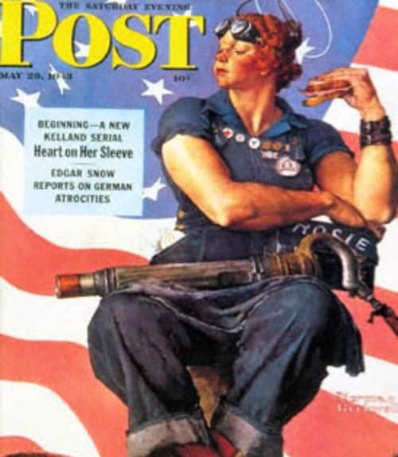

a. Women’s rights and capabilities

b. Encouragement for troops being deployed

c. Recruiting women to enlist

**d.** **For women to support war efforts**

3. Point out the underlying theme of these three pieces of propaganda:

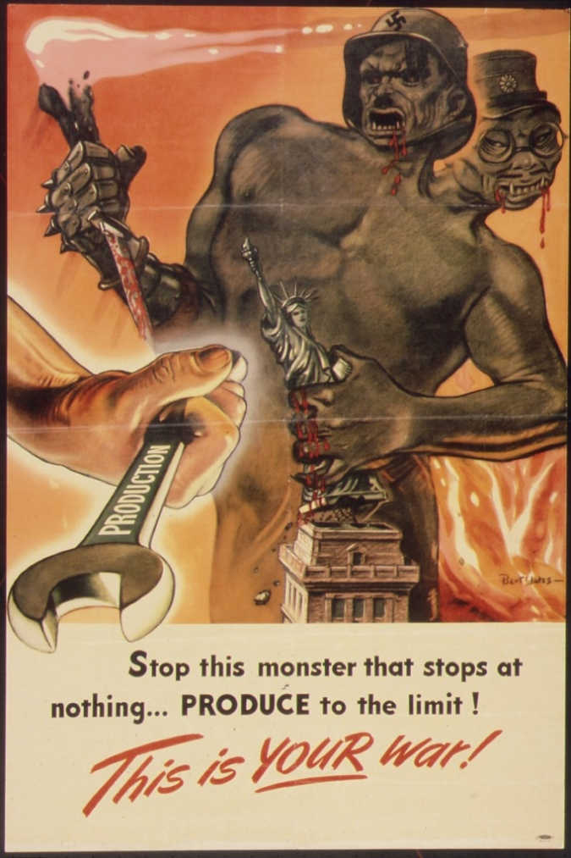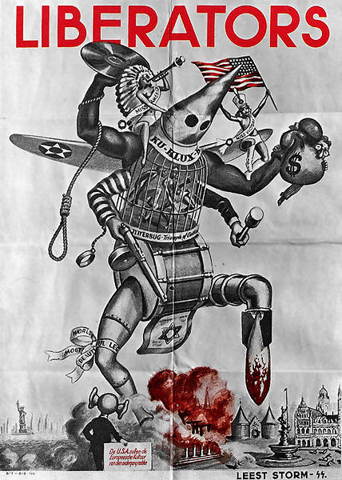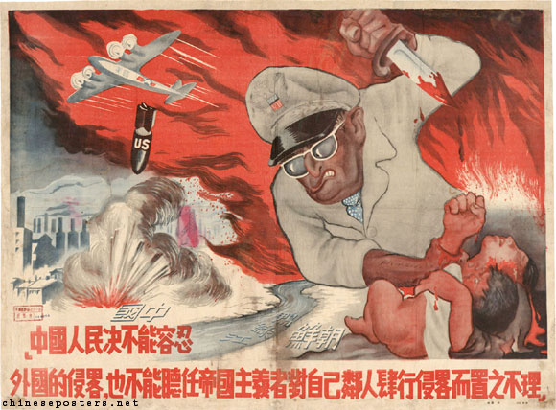

a. Racism

b. Power

c. Hatred

**d.** **Perspective**

4. The production of propaganda during the Cold War affected the economy in what way?

a. Increased the number of enlisted civilians to support war efforts.

**b.** **Increased employment through print facilities for propaganda**

c. Decreased employment for artist in magazines and newspapers

d. Decreased the number of journalist reporting on war efforts.

True/False

**True/False Instructions:** Determine if the statement is true or false, then circle either true or false for each statement. This section is worth a total of 26 points.

5. [Rosie the Riveter](http://www.emlii.com/images/article/2014/07/53bd24d21bb73.jpeg) was a character, often seen in propaganda, used to promote women on the battlefield. True/**False**

6. In the article, [Propaganda as a weapon](https://www.bl.uk/world-war-one/articles/propaganda-as-a-weapon), the modern technological inventions of mass printing and “commercial publishers were used to give the impression that works were produced independently of state direction.” This promoted sympathy in the common people by allowing them to infer these opinions were free of political agenda. **True**/False

7. This [WW2 propaganda](http://anglotopia.wpengine.netdna-cdn.com/wp-content/uploads/2011/10/british_3_World_War_Two_Propaganda_Posters-s320x428-48185-580.jpg) piece, implements the technical advancements of one military over another to influence people’s support of war efforts. **True**/False

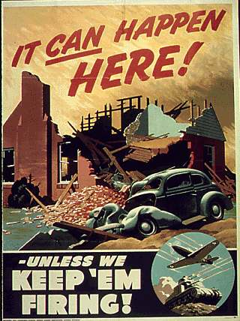



8. As a result of war efforts in 1942, the production of non-military essential items were placed on hold. This flag was used to indicate that at least half of the company’s employees contributed 10% of their income to war bonds. True/**False**

9. The phrase “loose lips sink ships” was used as a reminder in the U.S. to be careful with information when conversing with others because the enemy could be listening and one could inadvertently reveal details on where U.S. military ships were positioned. **True**/False

Source: [Loose lips sink ships](https://en.wikipedia.org/wiki/Loose_lips_sink_ships)

Fill in the Blank

**Instructions:** Complete each statement below by filling in the missing word. This section is worth a total of 16 points.

10. The main purpose of propaganda posters used by many governments was/is to __________ (Possible answers: **coerce, persuade, manipulate**).

Source: [100 Years of Propaganda, the Good, the Bad and the Ugly](https://www.smashingmagazine.com/2010/06/100-years-of-propaganda-the-good-the-bad-and-the-ugly/)

11. The “Golden Age of Propaganda” occurred during __________________ (this time in history). (Possible answers: **World War I or World War II**).

Source: [Propaganda History](https://en.wikipedia.org/wiki/Propaganda)

Matching

**Matching Instructions:** Match the best possible answer on the right to the statement on the left. This section is worth a total of 24 points

Given the article [“Nazi Propaganda”](https://www.ushmm.org/wlc/en/article.php?ModuleId=10005202) by United States Holocaust Memorial Museum (ushmm.org), evaluate your knowledge of the famous 1937 Nazi propaganda poster known as [*The Wandering Jew/ Der-Ewige-jude*](https://s-media-cache-ak0.pinimg.com/236x/af/92/0b/af920b2b3c5b4ba4824f18ae32351aaf.jpg) by Horst Schlüter to match the BEST answer to the following statements (#12 to 15).



|  |  |
| --- | --- |
| **Statements** | **Possible Answers** |
| 12. The piece of art affects the view of Jews’ social and economic status in German society. ____ (d) | a. Uses stereotypes to mislead perspectives, such as Zionism. (14.) |
| 13. An artistic solution to recreate the poster, or design something new, in a way that promotes and encourages the “melting pot” idea of a society. ____ (b) | b. Uses symbolism to promote diversity. (13.) |
| 14. The influence of exploitation on traditional Jewish stories and their impact on the general public. ____ (a) | c. Uses symbolism to encourage cults. |
| 15. The analysis of the poster could be skewed to encourage assimilation of the Jewish culture into the German public. ____ (e) | d. Uses symbolism in a negative connotation. (12.) |
|  | e. Uses stereotypes to promote trends. (15.) |
|  | f. Uses stereotypes to build segregation. |

**Performance-based Test**

**Objective:** Given the history and visual examples of political posters and propaganda from the 20th Century, students will create an original poster addressing a current issue or event of their choice that persuades the audience through the use of color, text, and images. (VA.912.H.3.2)

**Poster Instructions:**

For this portion of the test you will demonstrate what you have learned in this unit of 20th Century Art History and political posters and propaganda by creating an original poster that addresses a current issue or event of your choice. Your poster must visually persuade the audience through the use of color, text, and images.

You will be given two in-class periods to develop your idea and create your poster with a third in-class period to finalize your poster and write an artist’s statement. Your finished printed poster (no larger than 12in x 18in) must be turned in at the end of the third class period. You may design your poster using a medium of your choice: a digitally created poster print, watercolor, acrylic, or colored pencil. Your poster will be evaluated using the rubric below. Use the rubric details to guide you during the creation and completion of your poster.

Complete the poster project by writing a two-paragraph artist statement detailing your design process. Your statement needs to clearly explain the rationale for the choices made in the piece.

**Project Time Frame:** Three in-class sessions (50 minutes x 3 = 150 minutes). The first two in-class sessions will be dedicated to the design and development of the poster. The third class session will be dedicated to finalizing the poster and producing a written artist’s statement (two paragraphs) to be submitted with the finished poster at the end of the third class.

|  |  |  |  |  |  |
| --- | --- | --- | --- | --- | --- |
| **Poster Rubric for 20th Century Art History Unit/Visual Arts** | | | | | |
| **Stated Objective** | **Not Present**  **0 points** | **Developing**  **10 point** | **Accomplished**  **15 points** | **Exemplary**  **20 points** | **Score** |
| **Poster identifies a current event or issue. (evaluation)** | Poster is missing the identifying a current event or issue. | Poster vaguely identifies the current civics/ event or issue. | Poster somewhat identifies the current civics/ event or issue, but unclear. | Poster clearly identifies the current civics/ event or issue. | **___/20** |
| **Poster is persuasive in its visual message of a current event or issue. (synthesis)** | Poster does not clearly visually draw attention to persuasive techniques:  fear tactics, empathy, traditional values, logic and reasoning, timing, or ethical issues. | Poster clearly addresses/calls out/visually draws attention to and uses 1 persuasive techniques:  fear tactics, empathy, traditional values, logic and reasoning, timing, or ethical issues. | Poster clearly addresses/calls out/visually draws attention to and uses 2 persuasive techniques:  fear tactics, empathy, traditional values, logic and reasoning, timing, or ethical issues. | Poster clearly addresses/calls out/visually draws attention to and uses 3 persuasive techniques:  fear tactics, empathy, traditional values, logic and reasoning, timing, or ethical issues. | **___/20** |
| **Cohesively includes the elements and principles of design and are clearly visible in the poster. Elements of Design include line, texture, color, shape/form, value, and/or space**  **Principles of Design include repetition, balance, emphasis, contrast, unity**  **(application)** | The Elements and/or Principles of Design are not visible in the poster. Elements – line, texture, color, shape/form, value, and/or space. Principles – repetition, balance, emphasis, contrast, unity | Cohesively included only 1 of the 6 Elements and/or Principles of Design are clearly visible in the poster. Elements – line, texture, color, shape/form, value, and/or space. Principles – repetition, balance, emphasis, contrast, unity | Cohesively included 2 of the 6 Elements and/or Principles of Design are clearly visible in the poster. Elements – line, texture, color, shape/form, value, and/or space. Principles – repetition, balance, emphasis, contrast, unity | Cohesively included 3 of the 6 Elements and/or Principles of Design are clearly visible in the poster. Elements – line, texture, color, shape/form, value, and/or space. Principles – repetition, balance, emphasis, contrast, unity | **___/20** |
| **Design Criteria: Incorporate:**  **· 2 colors,**  **· A block of text, AND**  **· At least 1 graphic image or photograph**  **· Printed Poster Dimensions: no larger than 12 inches by 18 inches**    **(application)** | Incorporated none of the 4 bullets:  · 1 color  · 1 block of text  · 1 graphic image or photograph  · Printed poster dimension size meets criteria by measuring 12 inches by 18 inches | Incorporated only 1 or 2 out of the 4 bullets:  · 1 color  · 1 block of text  · 1 graphic  image or photograph  · Printed poster dimension size meets criteria by measuring 12 inches by 18 inches | Incorporated 3 out of the 4 bullets:  · 1 color  · 1 block of text  · 1 graphic  image or photograph  · Printed poster dimension size meets criteria by measuring 12 inches by 18 inches | Incorporated 4 out of 4 bullets:  · 1 or more colors  · 1 block of text  · 1 graphic  image or photograph  · Printed poster dimension size meets criteria by measuring 12 inches by 18 inches | **___/20** |
| **Artist Statement**  **(analysis)** | Poster is missing an artist’s statement to assist in viewer understanding. | Poster includes less than a paragraph artist’s statement to assist in viewer understanding, but is vague and unclear. | Poster includes only one paragraph in the artist’s statement to assist in viewer understanding that clarifies some aspects of the piece. | Poster includes a two-paragraph artist’s statement to assist in viewer understanding that clearly explains the rationale for the choices made in the piece. | **___/20** |
|  |  |  |  | **Total** | **___/100** |