EME 6613

Department of Defense

Acquisition Process - Proposal Review

Flowcharts, Storyboards and Instructor Guide

Prepared by:

Team Omega

John Barnocky

Frederick Dupuy

Rebecca Harrison

Gabriel Yeager

Prepared for:

Dr. Atsusi Hirumi

Table of Contents

Table of Figures 3

Table of Tables 3

Course Description 4

Flowchart 4

Flowchart for Unit of Instruction 5

Course of Instruction Flowcharts 6

Storyboards 11

Lesson 4100 Conduct a data search using Past Performance Information Retrieval System 12

Lesson 4200 Evaluating Relevancy of Past Performance 25

Lesson 4300 Evaluating Quality of Past Performance 25

Lesson 4400 Assign a Confidence Assessment Grade 25

Instructor Guide 26

Introduction 26

Course Overview 26

Course Organization 26

Course Coordination 28

Target Audience 28

Course Goal and Outcomes 28

Course Goal 28

Course Outcomes 28

Class Size 29

Host Agency Responsibilities 29

Audiovisual Equipment Requirements 29

Room Requirements 29

Local Coordinators Responsibilities 29

Training Site 29

Participants and Instructors 30

Final Arrangements 30

Student Requirements 31

Course Agenda 32

Instructor: Presentation Requirements 32

Before the Training Event Preparation List 32

During the Training Event 33

After the Training Event 33

Lesson Plans 33

Unit 0 Course Introduction 34

Unit 1 Review Initial Proposal 34

Unit 2 Document Discrepancies and Provide Feedback 34

Unit 3 Prepare Evaluation Package 34

Unit 4 Evaluate Past Performance 34

Unit 5 Evaluate Technical Proposal 39

Unit 6 Evaluate Cost Proposal 39

Unit 7 Brief Evaluation Results 39

Unit 8 Provide Feedback 39

# Table of Figures

Figure 1 Instructional Outline 5

Figure 2 Course Flow 6

Figure 3 Unit 4 Flow 7

Figure 4 Lesson 4.1 Detailed Flow 8

Figure 5 Lessons 4.2 – 4.4 Flow 9

Figure 6 Assessment detail flow 10

Figure 7 Course Overview 26

# Table of Tables

Table 1 High Level Course Organization 27

Table 2 Unit 4 Lesson Sequence 27

# Course Description

The Naval Air Warfare Center Training Systems Division (NAWCTSD) is required to follow the DoD process in procuring new equipment. Training of NAWCTSD contracts management personnel is needed to help them understand this process. This course is F2F and includes a group activity that requires the learners to conduct the past performance evaluation process.

# Flowchart

The flowchart (Figure 1) depicts the instructional outline for the Department of Defense Source Selection Team Training. This week-long course will help contracting specialists and other members of the Source Selection Evaluation Board (SSEB) understand how to evaluate proposals submitted for the acquisition process.

The contracting officer is responsible for establishing the SSEB, tailored to the particular solicitation, that includes personnel from contracting, legal, logistics, technical, and other expertise to ensure a comprehensive evaluation. These individuals must have a thorough understanding of the evaluation process to be a part of the evaluation team. Candidates for the evaluation team typically have 4 to 5 years of experience in their position before they are eligible for consideration.

The team is responsible for conducting a thorough evaluation of past performance, to include information that is not submitted in proposals, to ensure that contracts are awarded to good performers rather than to good proposal writers.

Prior to the beginning this training, each member will receive a copy of the solicitation, acquisition strategy, and rating scale to gain a high-level familiarity with the requirements. In accordance with Federal Acquisition Regulations, a training session is provided to all appointed evaluation team members to prepare them for the evaluation process. This training session includes an overview of these documents and the source selection process, with detailed training on how to properly document each proposal’s strengths, weaknesses, and risks.

Prior to attending the face to face (F2F) training session, the students will complete online courses to ensure that they have the prerequisite knowledge to participate in group activities. As shown in the flowchart (Figure 2), the students will access the course using Navy Knowledge Online (NKO). Each unit has specific goals and objectives. The students can complete the units in any order. As an example of a typical unit, Figures 3, 4 and 5 depict the structure for Unit 4.

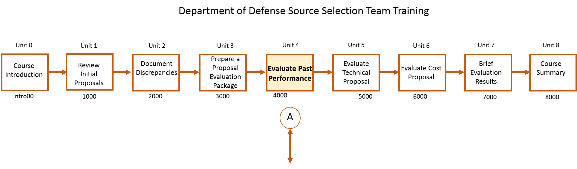

Figure Instructional Outline

## Flowchart for Unit of Instruction

The flowchart (Figure 2) depicts the instructional outline for Unit 4: Past Performance Evaluation. This two-day training event teaches contracting specialists and other members of the Source Selection Evaluation Board (SSEB) how to evaluate the past performance of companies who submit offers for current solicitations. This information is critical when determining whether a company meets the requirements outlined in the solicitation.

During the past performance evaluation, the source selection team considers the contractor’s recent and relevant record of performance for other services and/or new equipment provided. The outcome should be a performance confidence assessment grade that rates “what the contractor has done previously” with “what the contractor states they will do this time”. The past performance evaluation has 3 aspects: Recency; Relevancy; and Quality.

## Course of Instruction Flowcharts

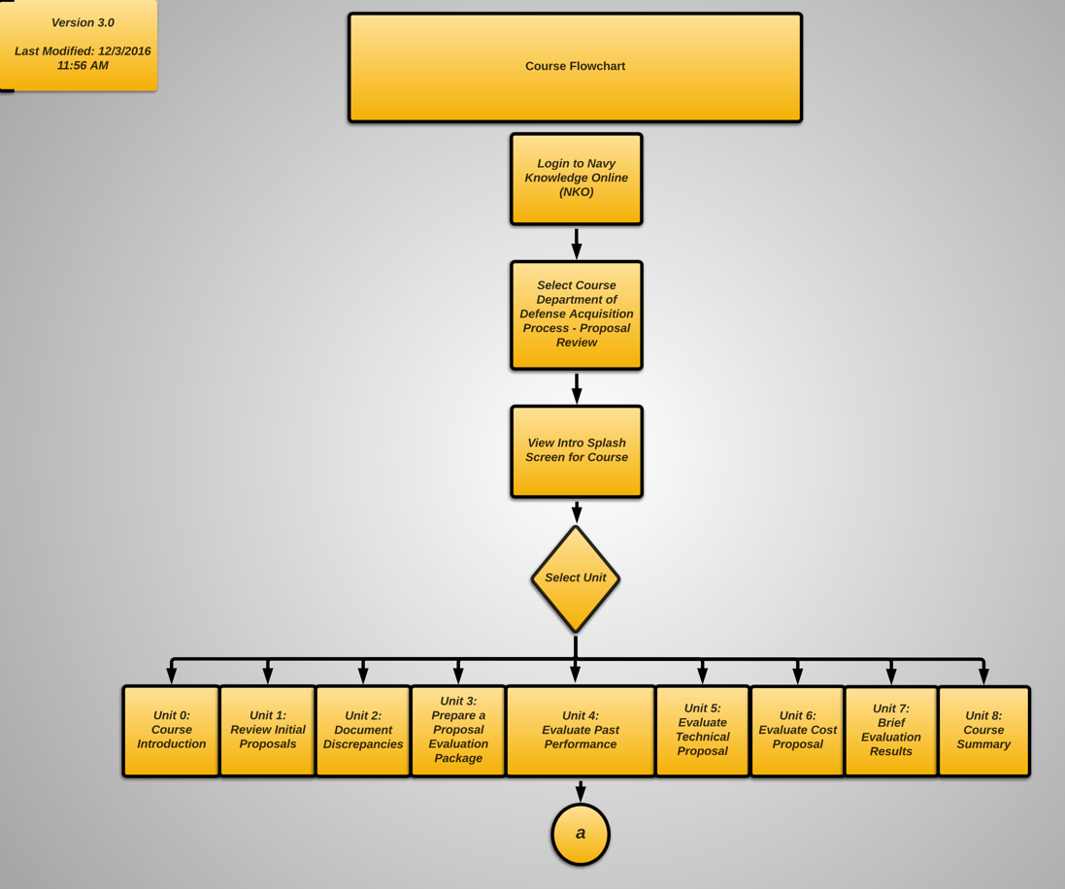

Figure Course Flow

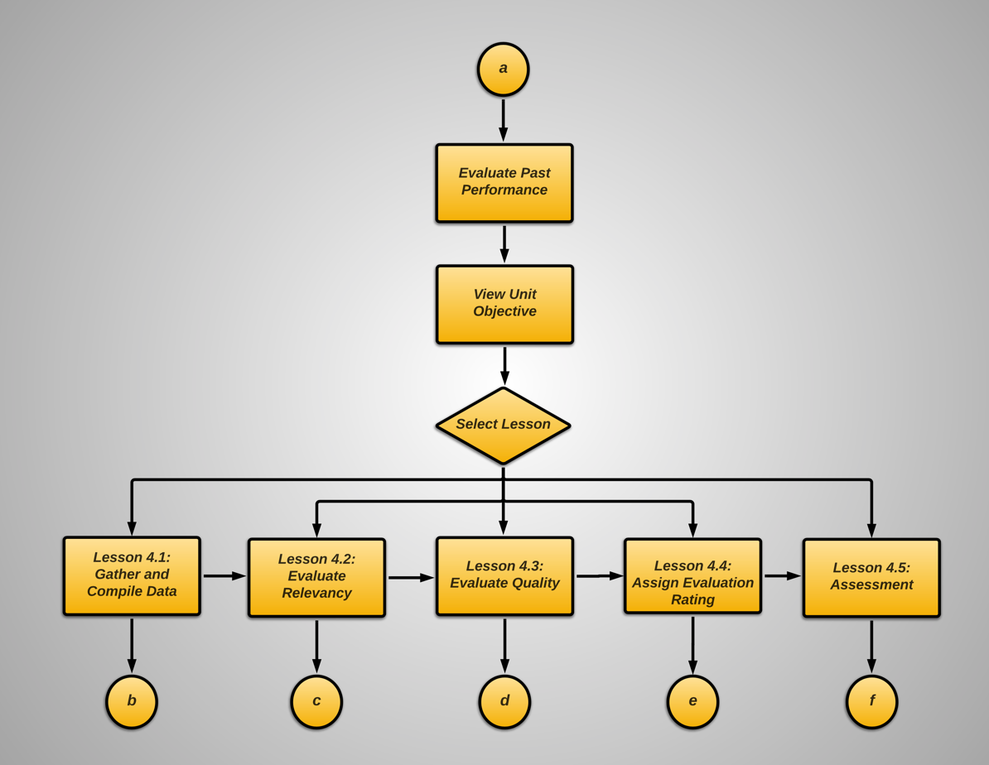

Figure Unit 4 Flow

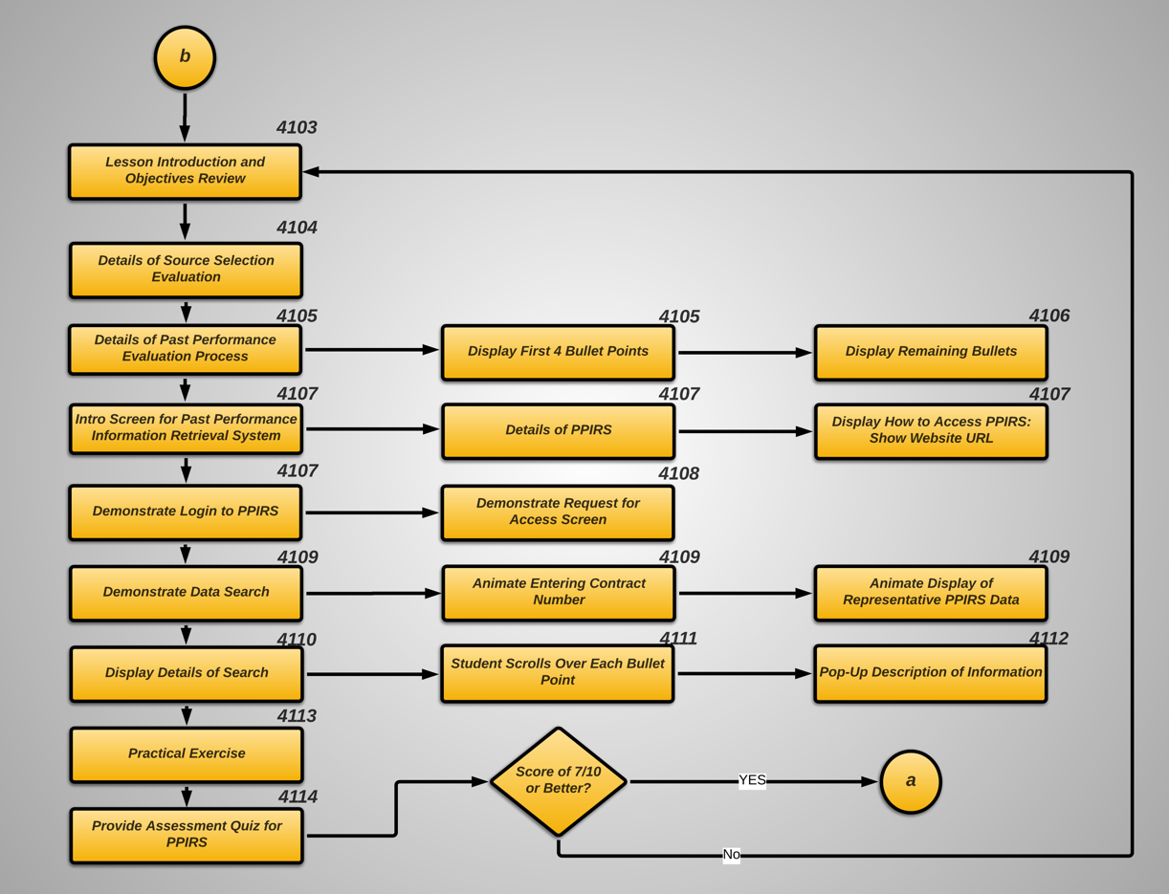

Figure Lesson 4.1 Detailed Flow

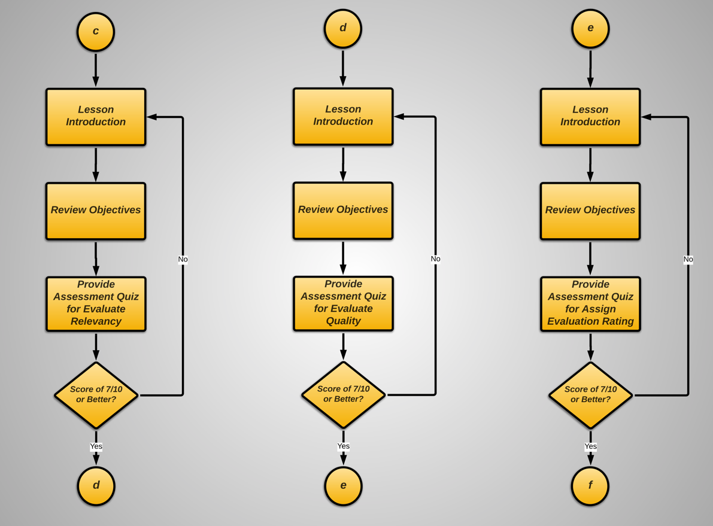

Figure Lessons 4.2 – 4.4 Flow

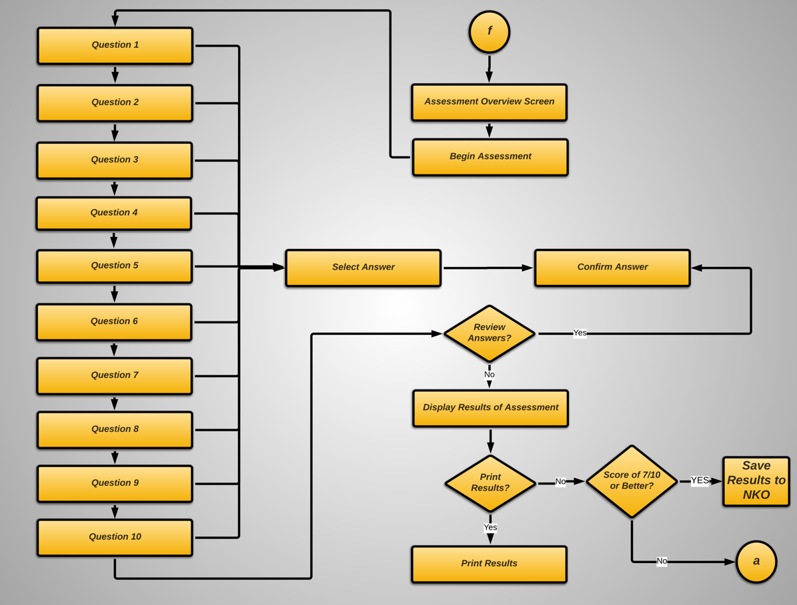

Figure Assessment detail flow

# Storyboards

**Unit Number and Title**: Unit 4 Conducting Past Performance Evaluations

**Objective(s):** Given the Past Performance section of a proposal and the request for

proposal, contracting officers will evaluate the submitted past performance following evaluation check sheet within established range for assessment.

**EOs:** After completion of this unit, students will be able to:

* Conduct a data search using Past Performance Information Retrieval System (PPIRS)
* Evaluate a proposal’s past performance section based on Relevancy and Recency
* Evaluate the quality of an offeror’s past performance
* Assign a confidence assessment grade and document the results of the analysis

## Lesson 4100 Conduct a data search using Past Performance Information Retrieval System

|  |  |  |  |  |  |
| --- | --- | --- | --- | --- | --- |
| DoD Proposal Review Training | | SB #: | Back: | Next: | |
| 4101 | N/A | 4102 | |
|  | | | | |
| Screen Title: | NKO Login Screen | | Display On-Screen | Y |
| Screen Type: | Online Instruction (via NKO) | | | |
| **Text On-Screen:** | | | | |
| DoD Proposal Review Training 28 Nov, 2016 | | | | |
|  | | | | |
| **Narration:** N/A | | | | |
| **Media Description:** The student logins into Navy Knowledge Online (NKO) and completes the online training prior to attending the face to face training sessions. The student selects the link (highlighted in the reference image) to the course to begin the training. In this example, the student will complete Unit 4: Past Performance Evaluations. | | | | |
| **Developer’s Notes:** Develop online training using the storyboards in accordance with the course outline. The students receive instructions to complete this training prior to the face to face sessions. Apply all media and project style standards to ensure the online training is Section 508 and SCORM compliant. | | | | |
| DoD Proposal Review Training | | SB #: | Back: | Next: | |
| 4102 | 4101 | 4103 | |
|  | | | | |
| Screen Title: | Course Navigation Menu | | Display On-Screen | Y |
| Screen Type: | Online Instruction (via NKO) | | | |
| **Text On-Screen:** | | | | |
| Unit 1: Review Proposal  Unit 2: Document Discrepancies  Unit 3: Prepare the Evaluation Package  **Unit 4: Evaluate Past Performance**  Unit 5: Evaluate Technical Proposal  Unit 6: Evaluate Cost Proposal  Unit 7: Brief Results  Unit 8: Provide Submitter Feedback  DoD Proposal Review Training | | | | |
|  | | | | |
| **Narration:** Select any unit from the course menu to begin. Although it is preferred, you do not have to take the eight units in order. Also, you can return to any unit before advancing to the next unit. If you exit the course, you will return to the same screen until you are finished with this course. If you are ready, select any unit to begin. | | | | |
| **Media Description:** After the student logs in and selects the course navigation is displayed. For this screen, create a high-resolution still image that shows members of the past performance team working in an office environment similar to the reference image shown on this storyboard. For consistency, use images of the actors from the demonstration video that will be shown later in this unit. | | | | |
| **Developer’s Notes:** Apply current media and style standards to the text and image displayed on this screen. | | | | |
|  | | | | |
| Unit: 4.0 / Title: Evaluate Past Performance | | SB #: | Back: | Next: | |
| 4103 | 4102 | 4104 | |
|  | | | | |
| Screen Title: | Lesson Introduction | | Display On-Screen | Y |
| Screen Type: | Online Instruction (via NKO) | | | |
| **Text On-Screen:** | | | | |
| Unit 1: Review Proposal  Unit 2: Document Discrepancies  Unit 3: Prepare the Evaluation Package  **Unit 4: Evaluate Past Performance**  Unit 5: Evaluate Technical Proposal  Unit 6: Evaluate Cost Proposal  Unit 7: Brief Results  Unit 8: Provide Submitter Feedback  This unit of instruction includes:   * Explanation of the Source Selection Evaluation Board (SSEB) * Conducting a Data Search using Past Performance Information Retrieval System (PPIRS) * Individual Practice Test   Unit 4: Evaluate Past Performance | | | | |
|  | | | | |
| **Narration:** This unit of instruction begins with a description of the roles for team members who comprise a Source Selection Evaluation Board, or SSEB. We will explore how to conduct a data search using the Past Performance Information Retrieval System. Before we start the learning about the past performance evaluation process, you will complete the practice test. The purpose of the test is to self-assess your understanding of the material and pre-requisite knowledge. Select NEXT to continue. | | | | |
| **Media Description:** Create a HTML screen with text and a high-resolution still image that shows members of the past performance team working in an office environment similar to the reference image shown on this storyboard. For consistency, use images of the actors from the demonstration video that will be shown later in this unit. | | | | |
| **Developer’s Notes:** This screen shows the unit introduction and should be consistent with the introduction screens in the other units. Apply current media and style standards to the text and image displayed on this screen. The Navigation menu on the left side of the screen allows the learner to select each unit in the course. | | | | |
| Unit: 4.0 / Title: Evaluate Past Performance | | SB #: | Back: | Next: | |
| 4104 | 4103 | 4105 | |
|  | | | | |
| Screen Title: | Source Selection Evaluation Board (SSEB) | | Display On-Screen | Y |
| Screen Type: | Online Instruction (via NKO) | | | |
| **Text On-Screen:** | | | | |
| Unit 1: Review Proposal  Unit 2: Document Discrepancies  Unit 3: Prepare the Evaluation Package  **Unit 4: Evaluate Past Performance**  Unit 5: Evaluate Technical Proposal  Unit 6: Evaluate Cost Proposal  Unit 7: Brief Results  Unit 8: Provide Submitter Feedback  Unit 4: Evaluate Past Performance  **Offer**  **Deficiencies**  **Strengths**  **Weaknesses**  The SSEB:   * Evaluates offers received. * Includes contract specialists, legal specialists, and program managers. * Requires people with the right skills, expertise, and experience. * Evaluates the deficiencies, strengths, weaknesses of each offer. | | | | |
|  | | | | |
| **Narration:** The SSEB is responsible for reviewing the offers and it includes various members from the contracting office, legal department, and program management office. It’s important to understand that the SSEB performs an in-depth and systematic evaluation of the offers using the evaluation factors outlined in the solicitation. | | | | |
| **Media Description: :** Create a HTML screen with text and a high-resolution still image that shows a member of the past performance team reviewing a written proposal similar to the image shown on this storyboard. For consistency, use images of the actors from the demonstration video that will be shown later in this unit. | | | | |
| **Developer’s Notes:** Apply current media and style standards to the text and animation displayed on this screen. The Navigation menu on the left side of the screen allows the learner to select each unit in the course. | | | | |

|  |  |  |  |  |  |
| --- | --- | --- | --- | --- | --- |
| Unit: 4.0 / Title: Evaluate Past Performance | | SB #: | Back: | Next: | |
| 4105 | 4104 | 4106 | |
|  | | | | |
| Screen Title: | Past Performance Evaluation Process | | Display On-Screen | Y |
| Screen Type: | Online Instruction (via NKO) | | | |
| **Text On-Screen:** | | | | |
| Unit 1: Review Proposal  Unit 2: Document Discrepancies  Unit 3: Prepare the Evaluation Package  **Unit 4: Evaluate Past Performance**  Unit 5: Evaluate Technical Proposal  Unit 6: Evaluate Cost Proposal  Unit 7: Brief Results  Unit 8: Provide Submitter Feedback  Unit 4: Evaluate Past Performance  The SSEB uses these steps to evaluate offers:  1. Perform pre-evaluation screening of offers.  2. Identify and document offer uncertainties.  3. Prepare a Proposal Evaluation Package.  4. Conduct a past performance evaluation. | | | | |
|  | | | | |
| **Narration:** The SSEB uses a standard process for the past performance evaluation.First, the contracting specialist will screen the written offers for compliance with solicitation instructions. Next, the contracting specialist will document any uncertainties. The other team members will prepare the proposal evaluation package to begin the past performance evaluation. The evaluators determine the level of risk to the Government based on the offeror’s demonstrated record of performance under similar contracts. Select NEXT to continue. | | | | |
| **Media Description:** Create an animation that shows a figure walking up a flight of stairs. When the figure reaches the top of the stairs, the figure is off screen but the stairs remain. | | | | |
| **Developer’s Notes:** Apply current media and style standards to the text and image displayed on this screen. | | | | |

|  |  |  |  |  |  |
| --- | --- | --- | --- | --- | --- |
| Unit: 4.0 / Title: Evaluate Past Performance | | SB #: | Back: | Next: | |
| 4106 | 4105 | 4107 | |
|  | | | | |
| Screen Title: | Past Performance Evaluation Process (contd) | | Display On-Screen | Y |
| Screen Type: | Online Instruction (via NKO) | | | |
| **Text On-Screen:** | | | | |
| Unit 1: Review Proposal  Unit 2: Document Discrepancies  Unit 3: Prepare the Evaluation Package  **Unit 4: Evaluate Past Performance**  Unit 5: Evaluate Technical Proposal  Unit 6: Evaluate Cost Proposal  Unit 7: Brief Results  Unit 8: Provide Submitter Feedback  Unit 4: Evaluate Past Performance  The SSEB uses these steps to evaluate offers (contd):  5. Identify and document deficiencies, strengths, weaknesses, and risks.  6. Assign ratings for non-cost evaluation factors.  7. Prepare a summary evaluation report. | | | | |
|  | | | | |
| **Narration:** The contracting officer is responsible for Identifying and documenting the deficiencies, strengths, weaknesses, and risks. This includes any ambiguous proposal language or instances in which the offeror failed to provide sufficient information. Next, the team assigns a rating for non-cost evaluation factors such as relevancy and recency. For the final step, the team prepares a summary evaluation report that includes the evaluated price; the final rating for each evaluation factor and sub factor; and a discussion of the associated strengths, weaknesses, deficiencies, and risks for each offer. | | | | |
| **Media Description:** Show the same figure from the previous animation at the top of the stairs with his arms waving to signify that he has finished the steps of the process. Use a different perspective from the previous animation as shown in the reference image on this storyboard. | | | | |
| **Developer’s Notes:** This is a continuation from the previous screen.Apply current media and style standards to the text and image displayed on this screen. | | | | |

|  |  |  |  |  |  |
| --- | --- | --- | --- | --- | --- |
| Unit: 4.0 / Title: Evaluate Past Performance | | SB #: | Back: | Next: | |
| 4107 | 4106 | 4108 | |
|  | | | | |
| Screen Title: | Past Performance Information Retrieval System (PPIRS) | | Display On-Screen | Y |
| Screen Type: | Online Instruction (via NKO) | | | |
| **Text On-Screen:** | | | | |
| Unit 1: Review Proposal  Unit 2: Document Discrepancies  Unit 3: Prepare the Evaluation Package  **Unit 4: Evaluate Past Performance**  Unit 5: Evaluate Technical Proposal  Unit 6: Evaluate Cost Proposal  Unit 7: Brief Results  Unit 8: Provide Submitter Feedback  Unit 4: Evaluate Past Performance  Conducting a Data Search  **SmithMr**  **PA$$W@RD1234** | | | | |
|  | | | | |
| **Narration:** To search for past performance information, you can log into the Past Performance Information Retrieval System website.Only authorized users such as Government users and contractors can log in to the website. This a is good time to remind you about the guidelines for safeguarding source selection information.The information stored on this database is sensitive and could harm contractors if the information is released to their competitors. | | | | |
| **Media Description: For this screen, s**how an animation of the PPIRS logon website. Create a close-up of the logon fields so that the image is readable. For the animation, enter a USERID and Password. Then, show a mouse pointer selecting the login button. Advance to the next image. The website is located at <https://ppirs.ppirs.gov/ppirs/checkpkicert.action>. | | | | |
| **Developer’s Notes:** Apply current media and style standards to the text and image displayed on this screen. | | | | |

|  |  |  |  |  |  |
| --- | --- | --- | --- | --- | --- |
| Unit: 4.0 / Title: Evaluate Past Performance | | SB #: | Back: | Next: | |
| 4108 | 4107 | 4109 | |
|  | | | | |
| Screen Title: | PPIRS Application Logon | | Display On-Screen | Y |
| Screen Type: | Online Instruction (via NKO) | | | |
| **Text On-Screen:** | | | | |
| Unit 1: Review Proposal  Unit 2: Document Discrepancies  Unit 3: Prepare the Evaluation Package  **Unit 4: Evaluate Past Performance**  Unit 5: Evaluate Technical Proposal  Unit 6: Evaluate Cost Proposal  Unit 7: Brief Results  Unit 8: Provide Submitter Feedback  Unit 4: Evaluate Past Performance | | | | |
|  | | | | |
| **Narration:** When you log into PPIRS for the first time, you will have to request access. You can request access using the link shown here. Select NEXT to continue. | | | | |
| **Media Description:** For this screen, create a high resolution still image of the PPIRS application screen. Add a red highlight as shown in the reference image. | | | | |
| **Developer’s Notes:** The image does not require any animation. Apply current media and style standards to the text and image displayed on this screen. | | | | |

|  |  |  |  |  |  |
| --- | --- | --- | --- | --- | --- |
| Unit: 4.0 / Title: Evaluate Past Performance | | SB #: | Back: | Next: | |
| 4109 | 4108 | 4110 | |
|  | | | | |
| Screen Title: | Searching for Contractor Information | | Display On-Screen | Y |
| Screen Type: | Online Instruction (via NKO) | | | |
| **Text On-Screen:** | | | | |
| Unit 1: Review Proposal  Unit 2: Document Discrepancies  Unit 3: Prepare the Evaluation Package  **Unit 4: Evaluate Past Performance**  Unit 5: Evaluate Technical Proposal  Unit 6: Evaluate Cost Proposal  Unit 7: Brief Results  Unit 8: Provide Submitter Feedback  Unit 4: Evaluate Past Performance | | | | |
|  | | | | |
| **Narration:** To search for past performance data, enter the contractor’s information in the fields as shown here.. | | | | |
| **Media Description:** Create a high resolution still image of the PPIRS contractor search screen. Apply highlights as shown in the reference image. | | | | |
| **Developer’s Notes:** Apply current media and style standards to the text and image displayed on this screen. | | | | |

|  |  |  |  |  |  |
| --- | --- | --- | --- | --- | --- |
| Unit: 4.0 / Title: Evaluate Past Performance | | SB #: | Back: | Next: | |
| 4110 | 4109 | 4111 | |
|  | | | | |
| Screen Title: | Results from the Data Search | | Display On-Screen | Y |
| Screen Type: | Online Instruction (via NKO) | | | |
| **Text On-Screen:** | | | | |
| Unit 1: Review Proposal  Unit 2: Document Discrepancies  Unit 3: Prepare the Evaluation Package  **Unit 4: Evaluate Past Performance**  Unit 5: Evaluate Technical Proposal  Unit 6: Evaluate Cost Proposal  Unit 7: Brief Results  Unit 8: Provide Submitter Feedback  Unit 4: Evaluate Past Performance | | | | |
|  | | | | |
| **Narration:** If the contractor has previously worked on a Government contract, the information will be displayed as shown here. You will notice that there is a lot of detailed information about the company and the previous contract. This is where you collect information to begin your past performance evaluation. Rollover each for more information. | | | | |
| **Media Description:** Create a high resolution still image of the PPIRS past performance assessment report. Use the reference image as an example. Ensure the text is readable image. Add rollovers for the text fields. | | | | |
| **Developer’s Notes:** Apply current media and style standards to the text and image displayed on this screen. | | | | |

|  |  |  |  |  |  |
| --- | --- | --- | --- | --- | --- |
| Unit: 4.0 / Title: Evaluate Past Performance | | SB #: | Back: | Next: | |
| 4111 | 4110 | 4112 | |
|  | | | | |
| Screen Title: | Result from the Data Search | | Display On-Screen | Y |
| Screen Type: | Online Instruction (via NKO) | | | |
| **Text On-Screen:** | | | | |
| Unit 1: Review Proposal  Unit 2: Document Discrepancies  Unit 3: Prepare the Evaluation Package  **Unit 4: Evaluate Past Performance**  Unit 5: Evaluate Technical Proposal  Unit 6: Evaluate Cost Proposal  Unit 7: Brief Results  Unit 8: Provide Submitter Feedback  Unit 4: Evaluate Past Performance  Contract Completion  Contract Management  Contract Schedule  Customer Satisfaction  Contracting Office Evaluation  Company Name: ACME Systems  Contract: NAWCTSD 2016-234-00174  Contract Type: FFP / Materials  Dates of Contract: 11082016-10302018  Remarks: The company met all of the requirements specified in the solicitation and the Statement of Work. The customer was satisfied with the delivery of the materials. The company received less than the highest ratings in 3 of the 5 areas due to management problems. The company had to modify the schedule several times due the contract period and eventually replaced the program manager. | | | | |
|  | | | | |
| **Narration:** Here’s an example of the past performance record from PPIRS. You can see that the evaluation includes ratings for Contract Completion, Management, and Project Schedule. The record also provides the Contracting Office and Customer evaluations of the company’s performance. | | | | |
| **Media Description:** Create a high resolution still image of the PPIRS past performance evaluation record. Use the reference image as an example. | | | | |
| **Developer’s Notes:** Apply current media and style standards to the text and image displayed on this screen. | | | | |

|  |  |  |  |  |  |
| --- | --- | --- | --- | --- | --- |
| Unit: 4.0 / Title: Evaluate Past Performance | | SB #: | Back: | Next: | |
| 4113 | 4112 | 4114 | |
|  | | | | |
| Screen Title: | Practical Exercise | | Display On-Screen | Y |
| Screen Type: | Online Instruction (via NKO) | | | |
| **Text On-Screen:** | | | | |
| Unit 1: Review Proposal  Unit 2: Document Discrepancies  Unit 3: Prepare the Evaluation Package  **Unit 4: Evaluate Past Performance**  Unit 5: Evaluate Technical Proposal  Unit 6: Evaluate Cost Proposal  Unit 7: Brief Results  Unit 8: Provide Submitter Feedback  Unit 4: Evaluate Past Performance | | | | |
|  | | | | |
| **Narration:** Now, it’s time for you to logon into PPIRS and search for past performance records. All of the information that you need is included in this interactive screen.” | | | | |
| **Media Description:** Create an interactive high resolution image of the PPIRS logon screen. The interactivity should allow the user to login and search for past performance information. Add rollover prompts for key information needed to login and to search. The website is located at <https://ppirs.ppirs.gov/ppirs/checkpkicert.action>. Use the reference image as an example. | | | | |
| **Developer’s Notes:** Apply current media and style standards to the text and image displayed on this screen. | | | | |

|  |  |  |  |  |  |
| --- | --- | --- | --- | --- | --- |
| Unit: 4.0 / Title: Evaluate Past Performance | | SB #: | Back: | Next: | |
| 4114 | 4113 | TBD | |
|  | | | | |
| Screen Title: | PPIRS Quiz | | Display On-Screen | Y |
| Screen Type: | Online Instruction (via NKO) | | | |
| Text On-Screen: | | | | |
| Unit 1: Review Proposal  Unit 2: Document Discrepancies  Unit 3: Prepare the Evaluation Package  **Unit 4: Evaluate Past Performance**  Unit 5: Evaluate Technical Proposal  Unit 6: Evaluate Cost Proposal  Unit 7: Brief Results  Unit 8: Provide Submitter Feedback  PPIRS Quiz  1. Conducting a Data Search Using Past Performance Information Retrieval System (PPIRS) includes which order from most basic to complex:  (a) Identify Contractor Value and identify Schedule and Identify Subcontracting and  Identify Period of Performance: identify Contractor Type and Identify Complexity: review  Contractor Performance Assessment Reports Systems (CPARS).  (b) Identify Contractor Type and Identify Complexity: Review Contractor Performance  Assessment Reports System (CPARS): Identify Contractor Value and Identify Schedule and Identify Subcontracting and Identify Period of Performance.  (c) Identify Contractor Value and identify Schedule and Identify Subcontracting and Identify Period of Performance: Identify Contractor Type and Identify Complexity: review Contractor | | | | |
|  | | | | |
| **Narration:** Complete the quiz for this section. Your goal is to get at least 7 out of 10 questions correct. If not, you must repeat this section. Good luck! | | | | |
| **Media Description:** Create an interactive quiz consisting of 10 questions. The student must get 7 of 10 correct. Use the reference image as an example. | | | | |
| **Developer’s Notes:** Apply current media and style standards to the text and image displayed on this screen. | | | | |

## Lesson 4200 Evaluating Relevancy of Past Performance

To be developed.

## Lesson 4300 Evaluating Quality of Past Performance

To be developed.

## Lesson 4400 Assign a Confidence Assessment Grade

To be developed.

# Instructor Guide

## Introduction

The Department of Defense Source Selection Team Training course provides training for contracting office personnel to conduct review and evaluation of proposals.

The contracting office for NAWCTSD is responsible for writing contracts and overseeing the procurement process for new equipment. The department’s employees must fully understand and participate in the acquisition process as members of a source selection team.

The primary function of the source selection team is to examine the requirements, facts, recommendations, and government policies that are applicable to a solicitation. A senior contracting specialist with NAWCTSD has recognized their organization’s current training methods are not properly preparing the department’s employees to serve as source selection team members. This deficiency often results in procurement delays and increased program costs.

## Course Overview

The flowchart (Figure 4) depicts the instructional outline for the Department of Defense Source Selection Team Training. This week-long course will help contracting specialists and other members of the Source Selection Evaluation Board (SSEB) understand how to evaluate proposals submitted for the acquisition process.



Figure Course Overview

Some of the units shown in (Figure 7) include online computer-based instruction delivered through Navy Knowledge Online (NKO). Material presented in the online portions of the course provide students with an opportunity to learn or refresh fundamental concepts needed to complete the course and to review proposals.

## Course Organization

The top-level sequence of the course is shown in Table 1.

Table High Level Course Organization

|  |  |
| --- | --- |
| **Unit #** | **Unit Title** |
| 0 | Course Introduction |
| 1 | Review Initial Proposal |
| 2 | Document discrepancies and provide feedback |
| 3 | Prepare Evaluation Package |
| 4 | Evaluate Past Performance |
| 5 | Evaluate Technical Proposal |
| 6 | Evaluate Cost Proposal |
| 7 | Brief Evaluation Results |
| 8 | Provide Feedback |

The details of Unit 4, Evaluate Past Performance, for the classroom portion are shown in Table 2 below. Unit 4 begins with an introduction into the Past Performance Evaluation process followed by a review of gathering data, material from the online lesson and information from the Past Performance Information Retrieval System (PPIRS). The first of three case studies is then provided to the group of students allowing them to interact with the PPIRS system to gather relevant information to evaluate a proposal.

Table Unit 4 Lesson Sequence

|  |  |
| --- | --- |
| **Lesson #** | **Lesson Title** |
| 1 | Evaluation of Past Performance Introduction |
| 2 | Review Conducting Data Search |
| 3 | Complete Past Performance Data Search Case Study |
| 4 | Review Evaluating Past Performance Proposal Process |
| 5 | Complete Evaluate Proposal Relevancy and Quality Case Study |
| 6 | Complete Evaluate Past Performance Case Study |

After reviewing the results of the first case study, a review of the past performance review process from the online lesson is reviewed and questions answered. The students are then presented the details of the second case study and are given the opportunity to review past performance examples using PPIRS data that is presented to them. This reinforces the expected level of data detail to be collected from PPIRS and helps to control the evaluation results. The students present the results of their evaluation to the group and the instructor and students provide feedback.

The students are then presented the final case study example of a complete Past Performance Evaluation. In this case study the students must complete all steps of the past performance evaluation process – gather data from PPIRS, evaluate the relevancy and quality and assign a confidence grade for three sample proposal responses. The groups then brief the results of their evaluation.

## Course Coordination

Facilitation of this course will be coordinated by the NAWCTSD Contracting Office Senior Manager and the contracted personnel for instruction. Primary communication is to be established by phone or email.

## Target Audience

The target population and typical learner is 28 years old and has a bachelor’s degree in business or finance. The learner has 1-3 years of work experience (this is an entry level position) and understands the acquisition process. The learner has not yet participated in the proposal evaluation process.

## Course Goal and Outcomes

### Course Goal

Goal Statement – As a member of the source selection team, NAWCTSD contracting personnel will evaluate proposals based on the following; Past Performance, Technical and Cost, in accordance with established Department of Defense and NAWCTSD policies and procedures.

### Course Outcomes

Learners in this class are to be confident in their ability to conduct a past performance analysis.

After completing this course, participants will be able to:

Excellent Performance

* Fully complete the past performance evaluation.
* Conduct a search using PPIRS and retrieved all of the information related to the contractor.
* Evaluate the proposal based on relevancy, recency, and quality.
* Assign the proper confidence grade and documented the results of the analysis.

## Class Size

To be determined.

## Host Agency Responsibilities

The requirements below should be carried out by the agency that requests the course session and are as follows:

### Audiovisual Equipment Requirements

Visual aids for this course consist of PowerPoint slides and video clips embedded in a webpage. The following audiovisual equipment is necessary for delivery of this course:

* SmartBoard connected to the internet
* Google Chrome installed on SmartBoard computer
* SmartBoard Markers and eraser
* Twenty-foot or longer extension cord

All equipment should be placed in the room for the instructors to check at least one hour prior to the first day of the course. The host should provide technical assistance during this time and contact information for technical assistance during the presentation of the course.

### Room Requirements

Onsite training room with tables containing computer workstations and a SmartBoard for the presenter to use.

### Local Coordinators Responsibilities

The local coordinator is responsible for preparing the site prior to the instructor’s arrival. Below is a checklist of the items the local coordinator should prepare prior to the instructors’ arrival. It is recommended that the instructors contact the local coordinator to ensure these steps have been taken.

### Training Site

Before the instructors’ arrival, the local coordinator should verify the following accommodations are in place for the training site:

* Selection of a training room is critical to the success of the course. Great care should be taken to select a room that will not be overcrowded, too hot or too cold, or subject to outside distractions. The instructor should contact you with any specific requirements for the training facility.
* Reserve a training room for the duration of the course.
* Check to see if anyone else will be using the room for nighttime functions.
* Determine if materials and equipment can be left in the room. Training courses requiring special equipment or computers must have after-hours security.
* Visit the classroom to make certain it meets all of the instructor’s requirements.

Other considerations for the training room:

* Heat or air conditioning-find out if the instructor can control these
* Adequate shape and size. No poles or obstructions
* Special arrangements for demonstrations, labs and experiments
* Seating arrangements
* Away from kitchen, construction area or other noise distractions
* Electrical outlets
* Lighting controls – Almost every training course uses visual aids that require a projection screen. It is important to have a room where lighting can be controlled to prevent glare on the screen while not placing the room in total darkness.

### Participants and Instructors

* If needed, reserve a hotel room for the instructor
* Participants and instructors should be:
  + Informed of course start and end times
  + Parking arrangements
  + Food accommodations local to the training site

### Final Arrangements

Two (2) weeks before the course:

* Check that all training materials have arrived:
  + Tent cards (large felt tip markers will be needed)
  + Evaluation forms
  + Class roster form
  + Student registration form
  + Certificates
* Reconfirm the training facilities.
* Discuss the seating arrangements and who will set-up the room.
* Discuss what time the room is unlocked/locked.
* Check to make sure a technician is available in case there are problems setting up the room or if something goes wrong during the course.
* Confirm any additional security needed for access to the building and classroom

One (1) week before the course:

* Prepare directional signs to classroom.
* Email to contractor and instructors the list of participant names (needed for Lesson 2 on Day 1 to be entered into an Excel Spreadsheet by instructor prior to course start date).
* No smoking signs should be posted in the classroom.
* Identify smoking areas.
* Determine if snacks are available.
* Identify where telephones are – both for participants to make outgoing calls and to receive incoming messages.
* Distribute a list of places for lunch, along with a map.
* Decide who will welcome the participants and introduce the instructors.
* Special check out arrangements may be made to coincide with the course completion time.
* Determine who will prepare the certificates of training and who will pass them out at the end of the course.

One (1) day before the course:

* Set-up the classroom.
* Organize the participant materials.
* Post directional signs.
* Test all equipment.

During the course:

* Let the instructor know whom to contact if he/she needs assistance.
* Provide a copy of the class roster to all course participants.
* Prepare certificates of training. The time needed to prepare them may be reduced and the appearance improved by using a computer with a graphics program and a laser printer.
* Check with the instructor at least once a day to resolve any problems.

After the course:

* Make certain the instructor has the class roster, course evaluation forms, and student registration forms. The instructor is responsible for reporting these to NAWCTSD.

### Student Requirements

In addition to the Reference Manual, NAWCTSD should provide notepads and pens, or instruct participants to bring notepads and pens with them. NAWCTSD is also responsible for providing computers for each student in the classroom to complete individual projects and assessments.

## Course Agenda

This course is to be taught over the course of one week, containing the six lessons listed below. The start of each day is to begin at 8:00AM, allow a one hour lunch break from noon to 1:00PM, and end at 5:00PM over the duration of a work week.

|  |  |
| --- | --- |
| **Time** | **Lesson Title & Description** |
| TBD | Course Introduction |
| TBD | Review Initial Proposal |
| TBD | Document discrepancies and provide feedback |
| TBD | Prepare Evaluation Package |
| TBD | Evaluate Past Performance |
| TBD | Evaluate Technical Proposal |
| TBD | Evaluate Cost Proposal |
| TBD | Brief Evaluation Results |
| TBD | Provide Feedback |

### Instructor: Presentation Requirements

### Before the Training Event Preparation List

Confirm the training dates, location, and number of participants.

1. Ensure you have the following materials:

* Instructor Guide, one copy for each instructor
* Secure webpage access relevant to lesson
* Attendance Sign-in Sheets
* Computer connected to the SmartBoard
* SmartBoard
* SmartBoard markers and eraser
* Learning Assessment
* Course Evaluation

1. Read and study the Instructor Guide, WebPage presentation material, and any company policies and procedures. Familiarize yourself with the examples that will be given in the lessons. Collaborate with local host/coordinator to determine who will print the following (available on website):

* Certification of completion for each participant.
* Evaluation forms.

1. Ensure the room is set-up properly (i.e., tables and chairs are arranged to maximize interaction, SmartBoard can easily be seen and interacted with, etc.).
2. Test the equipment.
3. Arrange materials so they are convenient for you and the participants. On the first day, ensure each participant's place has:

* One name tag and one name tent.
* One pen and pad (unless participants have been instructed to bring their own).
* One black marker for every two participants (so they can write their names on their name tags and name tents).

### During the Training Event

1. Arrive early. Give yourself plenty of time to get organized.
2. Circulate the Attendance Sign-in Sheet each day and after lunch each day. Be sure all participants sign-in.
3. Start on time and stay on track. Always start on time, even if only one participant is in the room. Keep exercises within their time limits. End discussions when they cease to be productive. Lead participants away from digressions and tangents and back to the lesson.
4. Be available during breaks, after class, and during site visits for questions.
5. Mentor participants during the activities. Walk among groups in class and on-site as they work on their activities, and answer questions and offer guidance as appropriate. Ensure participants are on track as they work. Give constructive feedback during the presentations and discussions.
6. Review Questions: Review the content of each lesson throughout the course to reinforce the learning outcomes for that lesson and to connect to upcoming material. As a general rule, review or discussion questions should be asked every 6-8 slides. Avoid YES or NO questions and try to use open-ended questions to draw participants into the material. Sample review questions are available in the Instructor's guide; however, you can also develop additional questions, as appropriate. Make sure all questions directly relate to and support the learning outcomes.
7. Lesson Outcomes: At the beginning of each lesson, review that lesson's outcomes. Make sure participants are fully aware of the topics to be addressed in the lesson. At the end of each lesson, review the outcomes once again using review questions or an activity/exercise to ensure the outcomes were met.

### After the Training Event

Have participants complete Learning Assessments and Course Evaluations. Collect the assessments and evaluations and submit them to NAWCTSD.

## Lesson Plans

The section beginning on the next page, contains the Lesson Plan for each lesson.

### Unit 0 Course Introduction

To be developed.

### Unit 1 Review Initial Proposal

To be developed.

### Unit 2 Document Discrepancies and Provide Feedback

To be developed.

### Unit 3 Prepare Evaluation Package

To be developed.

### Unit 4 Evaluate Past Performance

#### Lesson 1 Evaluation of Past Performance Introduction

To be developed.

#### Lesson 2 Review Conducting Data Search

To be developed.

#### Lesson 3 Complete Past Performance Data Search Case Study

To be developed.

#### Lesson 4 Review Evaluating Past Performance Proposal Process

To be developed.

#### Lesson 5 Complete Evaluate Proposal Relevancy and Quality Case Study

| **Event** | **Instructor’s Notes** |
| --- | --- |
| **Goal** | **Goal**   1. Review the Enabling Objectives related to evaluating a proposal’s past performance section 2. Review the Lesson Objective  * Given PPIRS Data for 2 companies, a request for proposal, and the past performance sections * Evaluate the Past Performance of each company and assign a Confidence Assessment Grade * Present the results of your evaluation to the group |
| **Reasons & Activation** | **Reasons & Activation**   1. Describe the information that will be provided to the evaluation teams, and the expectations for their analysis 2. Review with students the role of contracting officer’s in evaluating proposals and specifically past performance. 3. Review the timeline and costs associated with development of a major training system acquisition. 4. Discuss the importance of accurately assessing the past performance of a company |
| **Demonstration** | **Demonstration**   1. Play the video animation reviewing the past performance evaluation process 2. Provide an opportunity for the students to ask questions 3. Break the class up into 4 – 5 person teams |
| **Application** | **Application**   1. Provide the student teams with evaluation packages 2. Allow the teams to proceed to breakout rooms to complete their evaluations 3. Monitor the activities of the groups as they work through their evaluations. 4. Answer questions and provide feedback to teams if needed |
| **Integration** | **Integration**   1. After the allotted time (TBD), bring the teams back to the classroom 2. Allow each team to present the results of their evaluation 3. Ask the non-presenting teams to provide feedback on the presentation 4. Facilitate a discussion of the conclusions drawn by each group 5. Facilitate a discussion of any issues that occurred. |
| **Assessment** | **Assessment**   1. Provide feedback to each team on strengths and weaknesses observed during their evaluation process 2. Discuss the results and conclusions of the actual past performance evaluation and results of the contract work. |

#### Lesson 6 Complete Evaluate Past Performance Case Study

To be developed.

### Unit 5 Evaluate Technical Proposal

To be developed.

### Unit 6 Evaluate Cost Proposal

To be developed.

### Unit 7 Brief Evaluation Results

To be developed.

### Unit 8 Provide Feedback

To be developed.